Music development plan summary:
Knowsley Central School

Overview
Detail | Information
Academic year that this summary covers | 2025-26
Date this summary was published | September 2025
Date this summary will be reviewed | September 2026
Name of the school music lead | Rhianna Egan
Name of school leadership team member with responsibility for music (if different) | Liz Kearney
Name of local music hub | Sefton and Knowsley Music Hub
Name of other music education organisation(s) (if partnership in place) | N/A

This is a summary of how our school delivers music education to all our pupils across three areas – curriculum music, co-curricular provision and musical experiences – and what changes we are planning in future years. This information is to help pupils and parents or carers understand what our school offers and who we work with to support our pupils’ music education.

Part A: Curriculum music
This is about what we teach in lesson time, how much time is spent teaching music and any music qualifications or awards that pupils can achieve.
Knowsley Central School uses Charanga online system to deliver Music. Please see the plan below.

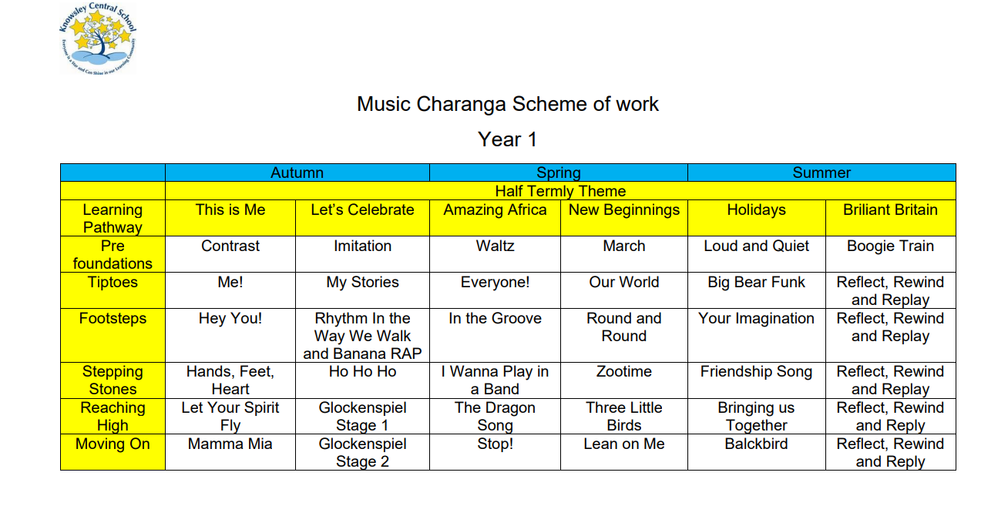
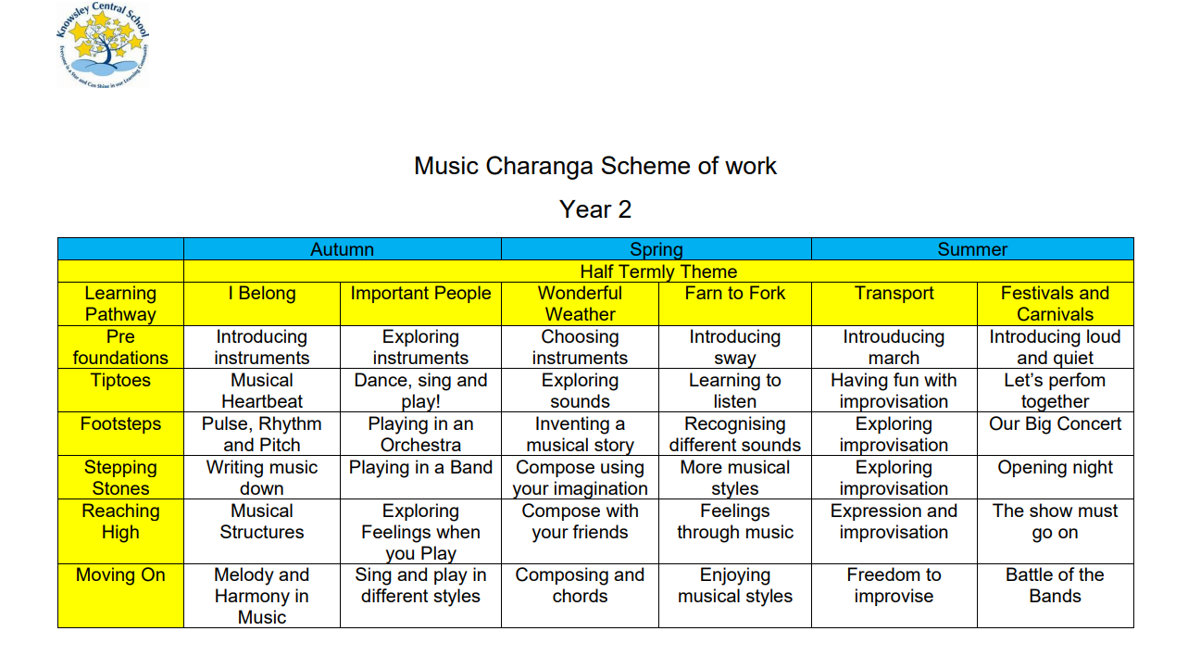
Knowsley Central School has seven curriculum pathways. Our children range from Early Years children to Engagement model learners and Progression Step learner. All are provided with the opportunity to access music through Charanga and this is delivered in either bespoke sessions or throughout the curriculum depending on the children’s individual needs.

Part B: Co-curricular music
This is about opportunities for pupils to sing and play music, outside of lesson time, including choirs, ensembles and bands, and how pupils can make progress in music beyond the core curriculum.
Many of the children within Knowsley Central are gestalt language processors, therefore song and rhymes are used throughout the school day to support the development of language. Music is used for transition times throughout the school day.
Knowsley Central School also provides music lunch time clubs delivered by teaching assistance who are experts in music, for children to learn instruments and to take part in singing songs. Children have opportunity to learn to play percussion instruments, guitars and keyboards along with taking part in singing This allows children to take part in focused sessions in smaller groups.

Part C: Musical experiences
This is about all the other musical events and opportunities that we organise, such as singing in assembly, concerts and shows, and trips to professional concerts.
At Knowsley Central School we support children who can take part in assemblies to participate to the best of their ability to sing and play instruments and move to music.
There are weekly assemblies for selected classes at specific times. This is timetabled appropriately. With class teachers leading on a rota basis.

To support children to experience music, school attempts to bring choirs, bands and musicians into school to perform at least once a term.
For those children who are able to access performances school will arrange Educational Visits to different performances.

Children who take part in the school lunch time clubs for music and dance will take part in performances for their peers and parent/carers when appropriate.

